**McKenzie - PAD**

**Database**

**Software Requirements Specification**

**Version 1.3**

**2017-05-09**

**SWTS1104**

**Author: Kyle Gunton**

# 

# Revision History

|  |  |  |  |
| --- | --- | --- | --- |
| **Date** | **Version** | **Author** | **Comments** |
| 2017-05-05 | 1.0 | Kyle Gunton | First Revision |
| 2017-05-08 | 1.1 | Kyle Gunton | Revisions made based on feedback |
| 2017-05-09 | 1.2 | Kyle Gunton | Revisions made based on feedback |
| 2017-05-09 | 1.3 | Kyle Gunton | Revisions made based on feedback, Corrected format based on IEEE SRS international standard document |
|  |  |  |  |
|  |  |  |  |
|  |  |  |  |
|  |  |  |  |
|  |  |  |  |
|  |  |  |  |
|  |  |  |  |
|  |  |  |  |
|  |  |  |  |
|  |  |  |  |
|  |  |  |  |
|  |  |  |  |

Table of Contents

Revision History 2

1. Introduction 5

1.1 Purpose 5

1.2 Scope 5

1.3 Product Overview 5

1.3.1 Product Perspective 5

1.3.2 Product Functions 5

1.3.3 User Classes and Characteristics 5

1.3.4 Limitations 6

1.4 Definitions & Descriptions 6

1.4.1 About the Game 6

2.0 References 9

3. Specific Requirements 9

3.1 User Interfaces 9

3.2 Hardware Interfaces 9

3.3 Software Interfaces 9

3.4 Functional Requirements 9

3.5 Performance Requirements 11

3.6 Usability Requirements 11

3.7 Logical Database Requirements 11

3.8 Design Constraints 11

3.9 Software System Attributes 11

3.10 Other Requirements 11

4.0 Verification 11

4.1 User Interfaces 11

4.2 Hardware Interfaces 11

4.3 Software Interfaces 11

4.4 Functional Requirements 11

4.5 Performance Requirements 11

4.6 Usability Requirements 12

4.7 Logical Database Requirements 12

4.8 Design Constraints 12

4.9 Software System Attributes 12

4.10 Other Requirements 12

Appendixes 12

Appendix A: Acronyms, and Abbreviations 12

Appendix B: Assumptions and dependencies 12

Appendix C: To Be Determined List 12

# 1. Introduction

## 1.1 Purpose

To identify the requirements and features of the McKenzie – PAD database.

## 1.2 Scope

In the Puzzles and Dragons database, a user will be able to create a player account, add and modify their monsters, create and modify teams using those monsters, and compare those teams to other monsters.

## 1.3 Product Overview

### 1.3.1 Product Perspective

A database containing a list of players and their monsters as well as their teams. It also includes the attributes, types, active skill, leader skill, awoken skills, and the max/min statistics for each monster class in PAD as well as the current information of each monster instance.

### 1.3.2 Product Functions

- User may view the properties of any monster class or instance

- User may create/view/modify player instances

- User may create/view/modify Monster instances attached to a player instance

- User may create/view/modify a team from monster instances

- User may view the list of monster classes

- User may modify/view the list of monster instances

- User may add/remove/view latent skill lists

- User may view latent skills

- User may view awoken skill lists

- User may view awoken skills

- User may view monster types

- User may view monster attributes

- User may view other players’ teams and monsters

### 1.3.3 User Classes and Characteristics

- Anyone who is able to navigate around a database system and use SQL may use it

- Opposable Thumbs (or be an octopus)

- Index finger

- Eyes

### 1.3.4 Limitations

- User’s device

- McKenzie-PAD Database will only be for Computers/Laptops while PAD game is only for mobile devices

- no way to directly access data from the Puzzles and Dragons Gung-Ho database.

## 1.4 Definitions & Descriptions

### 1.4.1 About the Game

**The Player**

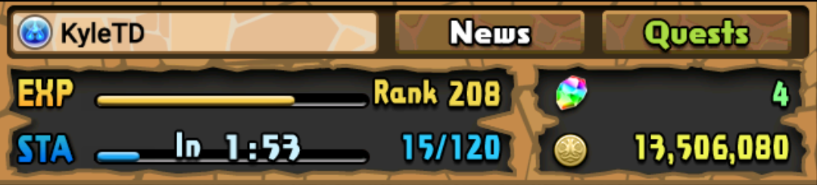

* A player is an account that contains a rank, name, Unique ID, starting attribute, magic stones, coins, monster points, stamina, and monster instances.
* Rank: An integer value determined by your current exp.
* ID: A unique integer identifier granted to each player upon account creation.
* Starting attribute: Determines player’s time group as well as their ID
* Magic Stones: In-game currency used to purchase monsters, refill stamina, increase friend slots, and to increase monster box slots.
* Coins: In-game currency used to purchase dungeons and upgrade monsters.
* Monster points: In-game currency used to purchase monsters.
* Stamina: an integer value based on level that allows you to enter dungeons only when it is sufficient.

**The Monsters**

* A monster holds a wide variety of properties that may be unique depending on the field.

In this screenshot, we can see some of the many fields attached to just one monster.

* 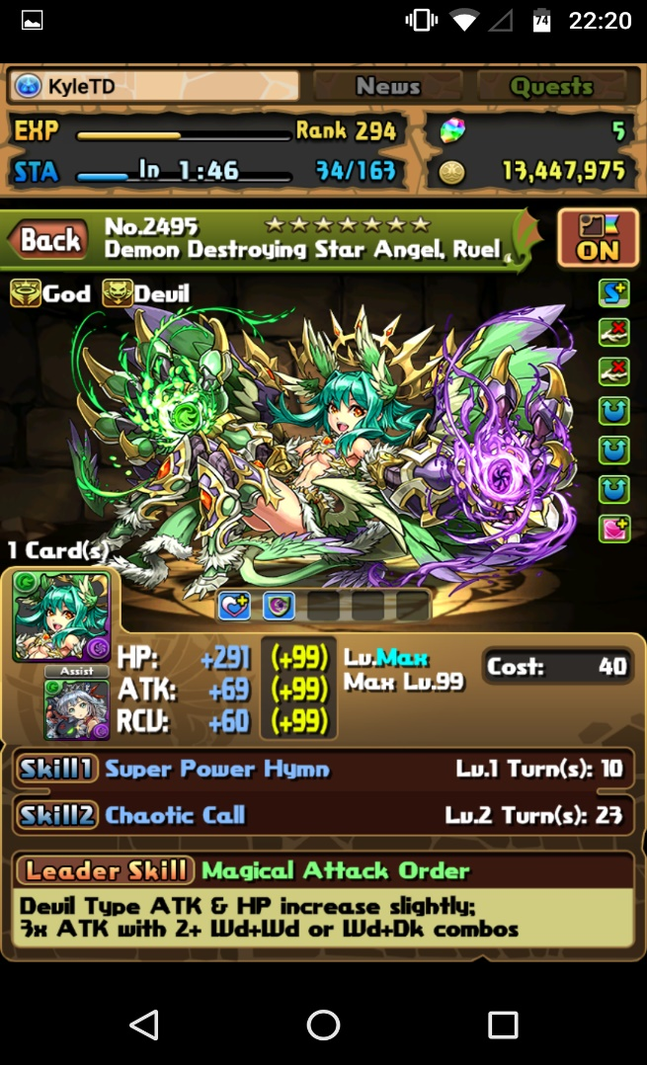Stats: HP/Attack/Recovery (This version is for the stat bonuses) (***RED***)
* Level: Current/max level/next level in (as well as a progress bar) (***yellow***)
* Skills: active skill/leader skill/second skill or assist skill (if they have any) (***green***)
* Cost (***light green***)
* Awoken skills: total for monster/awoken/yet to awaken (***Blue***)
* Latent awoken skills (***light blue***)
* Monster type: 1 top 3 of 12 possible types (***purple***)
* Attribute: 1 to 2 of 5 possible attributes (***pink***)
* Rarity: 1 to 10 stars (***cyan***)
* Monster name (***black***)
* Favorite: if the monster is listed as favorite or not (***mauve***)
* Number of the same monster you own (***grey***)
* Assisted monster (***white***)
* Active Skill: An ability monsters can use in dungeons to modify the board, the player or the enemies.
* Leader Skill: An ability that buffs the player’s team based on the leader monster.
* Awoken Skill: A boost granted to a monster.
* Latent Awoken Skills: A type of awoken skill that you assign to a monster.
* Assist Monsters: Monsters can become assists for other monsters. The assisted monster gains the active skill of the assisting monster as well as a possible stat boost. Not all monsters can be assists.
* Monster Types: Monsters have 1-3 types. There are currently 12 different types a monster may have.
* Attribute: All monsters have a primary element and they can have a secondary element. There are 5 elements that can be chosen form. Fire, Water, Wood, Light, and Dark.
* Monster Name: All monsters have a name that are unique (if only by case).
* Monster ID: All monsters have unique integer ID’s.
* Evolution: Monsters can evolve/devolve into other monsters when certain conditions are met.
* Stats
  + Level: Monster level based on current experience.
  + HP: Health of a monster.
  + ATK: Attack of a monster.
  + RCV: Recovery of a monster.
  + + stats: bonus stats applied to HP, ATK, and RCV.
  + Other stats boosts (Blue stats) are stat boosts granted from assisting monsters of the same attribute(s) as well as awoken/latent skills.
  + Has one of three growth rates and can be modifies by + stats as well as by assists, awoken skills and latent skills.
  + Cost: Monster cost that used to limit the number of powerful monsters that can enter a team.
  + Rarity: An indicator of how common or uncommon a monster is.

**The Team**

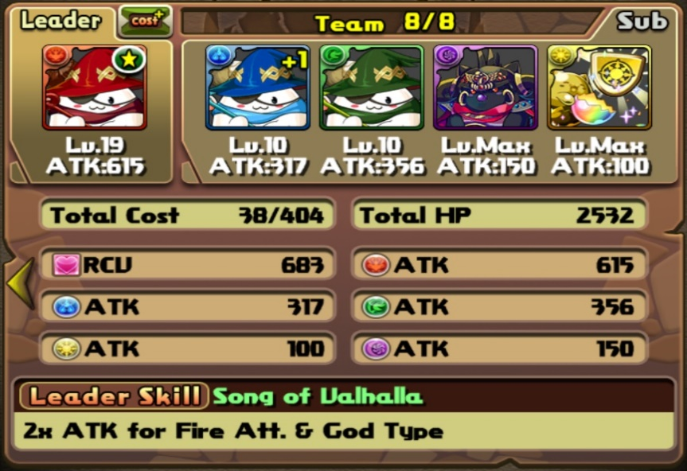

* A team a group of monsters made up of 1 leader monster and 0-4 sub monsters.
* Monsters costs cannot exceed the max team cost
* Each team may be assigned a badge
* Team RCV is calculated by adding all monsters RCV together
* Team HP is calculated by adding all monsters HP together
* Each attribute ATK is calculated by the ATK of each monster with that element as their primary attribute plus 1/3 it’s ATK from their secondary unless their secondary and primary is the same in which case it is plus 1/10

# 2.0 References

ISO/IEC/IEEE 29148-2011 SRS International Standard Document

<http://ieeexplore.ieee.org/document/6146379/>

# 3. Specific Requirements

## 3.1 User Interfaces

- MS SQL Management Studio

## 3.2 Hardware Interfaces

- Desktop Computer/Laptop

- Mobile Devices

## 3.3 Software Interfaces

- MS SQL Management Studio

## 3.4 Functional Requirements

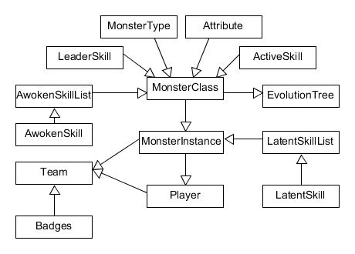

Info from -> used in

MonsterClass

* A collection of blueprints of all monsters’ base information is stored in this table

MonsterInstance

* A collection of monsters based on blueprints from MonsterClass that has been given a unique instance ID and player ID.

Attribute

* All monsters have a primary and a possible secondary element that they will pull from this table

MonsterType

* All monsters currently have 1-3 types consisting of the records d they pull from this table

ActiveSkill

* Monster classes pull the information (Name, Desc., MaxLevel, MaxCooldown) on their active skills from this table

LeaderSkill

* All monsters can have a leader skill. The leader skill is an ability that grants the user a boost when certain conditions are met.

AwokenSkill

* Awoken skills are small boosts attached to monsters. All monster instances of the same base monster class have the same awoken skills in the same order. A monster can currently have up to nine.

AwokenSkillList

* A list of a monster classes’ awoken skills in order from one to nine.

EvolutionTree

* Monsters generally have the ability to evolve/devolve (change into another monster) under certain circumstances. This table records the different stages a monster instances may go through.

Player

* This table records information important to identifying a player including their in-game id, Name, and rank amongst others.

Team

* The team table is made up of the player’s id it belongs to, its name and anywhere from one to five monster instances. It also includes a badge that will give a boost to the team in dungeons.

Badges

* Badges may be assigned to teams (one badge may go to many teams) to grant that team a boost (stat, monster cost, etc.)

LatentSkill

* All monster instances can have at least 5 latent skills and up to 6 under certain circumstances. Lists all the latent skills available and their descriptions.

LatentSkillList

* A collection of which monster instances have which latent skills.

## 3.5 Performance Requirements

## 3.6 Usability Requirements

## 3.7 Logical Database Requirements

## 3.8 Design Constraints

## 3.9 Software System Attributes

* A list of a monster classes’ awoken skills in order from one to nine.
* Reliability
* Availability
* Security
* Maintainability
* Portability

## 3.10 Other Requirements

# 4.0 Verification

## 4.1 User Interfaces

## 4.2 Hardware Interfaces

## 4.3 Software Interfaces

## 4.4 Functional Requirements

## 4.5 Performance Requirements

## 4.6 Usability Requirements

## 4.7 Logical Database Requirements

## 4.8 Design Constraints

## 4.9 Software System Attributes

## 4.10 Other Requirements

# Appendixes

## Appendix A: Acronyms, and Abbreviations

PAD = Puzzles and Dragons

Exp = Experience

Desc = Description

HP: Health

ATK: Attack

RCV: Receive

+ = Plus

AS = Awoken Skill

LS = Latent Skill

Req = Requirement

## Appendix B: Assumptions and dependencies

- information gathered is accurate

- all monsters follow the same guidelines

## Appendix C: To Be Determined List

3.5 Performance Requirements

3.6 Usability Requirements

3.7 Logical Database Requirements

3.8 Design Constraints

3.9 Software System Attributes

3.10 Other Requirements

Section 4.0

Index